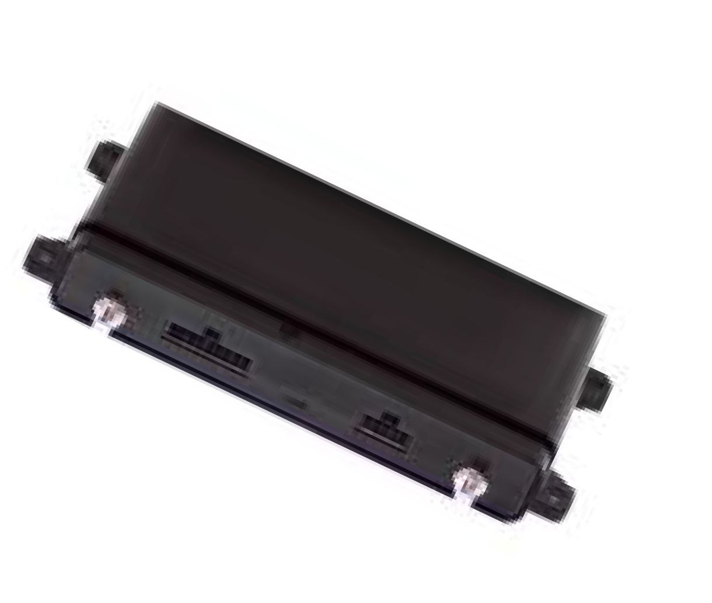
EZ-750

DEVICE DESCRIPTION
The EZ-750 is our most advanced ﬂeet tracking device incorporating 4G technology, including both Bluetooth and a WiFi hotspot for connectivity with our VS-800 Video Camera solution. The device is designed to handle our most advanced functions, for example, it will support the monitoring of many optional features, such as multiple inputs for PTO (power take off), SID (Starter Interrupt/Disable) and remote Door Unlock. Its Bluetooth module provides flexibility for future features, like Driver ID and Driver based applications. It is built with the quality components needed to meet the high reliability and the large amounts of data required as a continuous ﬂeet tracking and video gateway device.

This product will support nearly all general business needs, especially those that want Video Camera functionality along with the visibility of vehicle PTO (power take off) activity such as identifying when a snow plow or truck bed’s position is raised or lowered or when any secondary engine is engaged. This device will also support Tow Alert notifications. We also categorize this
device as our “gateway” device and suggest it be sold to any user that might want our video solution in the future.
FLEET

KEY FEATURES/BENEFITS

- Reports every 20 seconds + heading changes of >10°.
- Internal dual Global cellular and GPS satellite antennas reduce installation time, improves cellular signal reception, and better supports a covert installation.
- Internal battery back-up allows us to report even if the device power is compromised, tampered with or disconnected.
- Capable of storing and forwarding all satellite tracking data (once the device recognizes cellular connectivity) up to 10,000 data points (which is critical, if and when any vehicle travels beyond a cellular network).
- Includes, “smart power management” which allows the device to recognize when a vehicle is turned off which triggers the device to go into a sleep mode, which will signiﬁcantly reduce the possibility of the device causing any vehicle battery issues.
- Utilizes the 4G LTE CAT 4 cellular networks to transmit all the vehicle generated data (an unlimited cellular data plan is included with your service). Which includes the best coverage of Verizon, T-Mobile and AT&T (in that network order) and when in Canada, the device will seek the Telus, Rogers and Bell cellular network (in that order) and Telefonica within the Mexico, Latin America and Caribbean
markets.
- Built Rugged and Secure – advanced security protocols and is RoHS, Reach and SAEJ1455 compliant

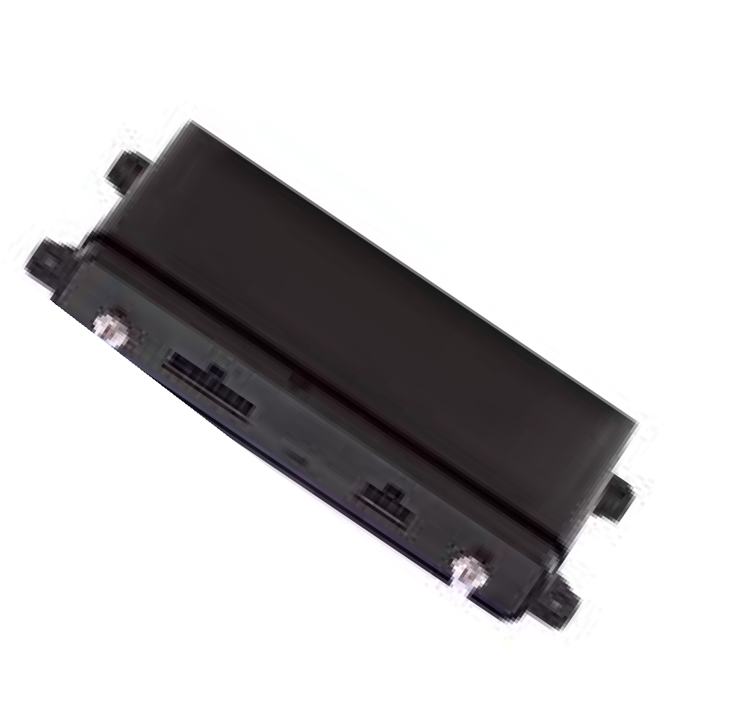
EZ-750

FLEET

DEVICE SPECIFICATIONS
Size: 7.3” x 3.23” x 1.22”
Weight: .63 lb. Operating Temp.Powered: -40° C to 70° C Battery: -20°C to 60°c Charging: 0° C to 45° C
Wireless Specs: Global LTE Modem CAT 4
Operating Voltage: 6-48 VDC Location Accuracy: +/-2.0m CEP Internal Back-up Battery 1.2 AH
Certifications: FCC, CE, IC, PTCRB, RCM Device LED’s: Power Button, 5 LED’s, Buzzer
Internal Antennas:
Cellular Primary & secondary GPS
WiFi Hotspot for Video Application only Bluetooth: 5.0 (master, slave LE data packet)
External Connectors:
USB
Power In (6-48VDC) Power Out (2.5W)
1 -Wire Technology
Digital Inputs x3 Outputs x2 Ignition Detection
CAN 2.0B x 1 (ISO-15765 or J1939) or FD x1 (ISO-15765 or J1939) RS-232 x2

DEVICE SOFTWARE HIGHLIGHTS
- Web based; providing access to your ﬂeet information limited only by your access to the internet; including a mobile viewer application that will auto size for smartphone or tablet.
- Fleet tracking updates every 20 seconds + heading changes of >7°
- Supports integration with our VS800 Video Camera solution for easyaccess to the key Video Alerts provided by our VS800.
- Supports “closest vehicle” worker dispatch functionality. Which provides accurate ETAs, reduces wasted time between jobs and improves customer relations.
- Provides real-time location, speed, heading, stopping and mileage reporting.
- Track maintenance schedules based upon real time mileage information.
- Provides hard braking and hard acceleration information to help eliminate unsafe driving behavior.
- Monitor idling to reduce fuel and unnecessary wear on your vehicle.
- Provides exact arrival and departure data relative to any task, which will increase billing accuracy and reduce billing write-offs and disputes.
- Provides the ability to create customized zones (landmarks) and receive data relative to the entering, exiting and time spent within each customized zone.
- Mapping with Google Street View and Google Earth integration.
- Unlimited users (no additional software license fees or charges).
- Custom Map Icons (including the ability to input actual photos of each of your vehicles and or drivers).
- Provides 24 months of historical tracking data on the reporting suite. Visually, you have access to 6 months data via our mapping tab.

OUR WARRANTY
We stand behind our equipment and software solution with our satisfaction guarantees
3-Year Device Warranty – If at any time during normal use your device stops working (excluding physical or water damage, or any change in cellular technology that renders the device obsolete) we will provide a replacement device at no charge. The commencement date is based upon the assignment of a billable rate plan to a device.
30-Day Money-Back – If at any time within 30 days after a device begins tracking you are not completely satisfied with your purchase or our soft- ware solution for any reason, we will give you a refund on the original purchase price of your device. (Not applicable with any leased/bundled program and does not include labor (if any)).

